PRESS Release

Brussels, June 14th, 2018

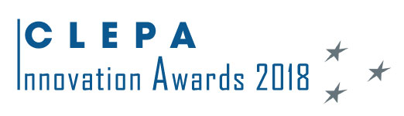
Bosch, Inteva, Plastic Omnium and TomTom winners of the
CLEPA 2018 Innovation Awards
Brigade, Navads and Voxdale first SMEs ever to receive dedicated “SME Award”

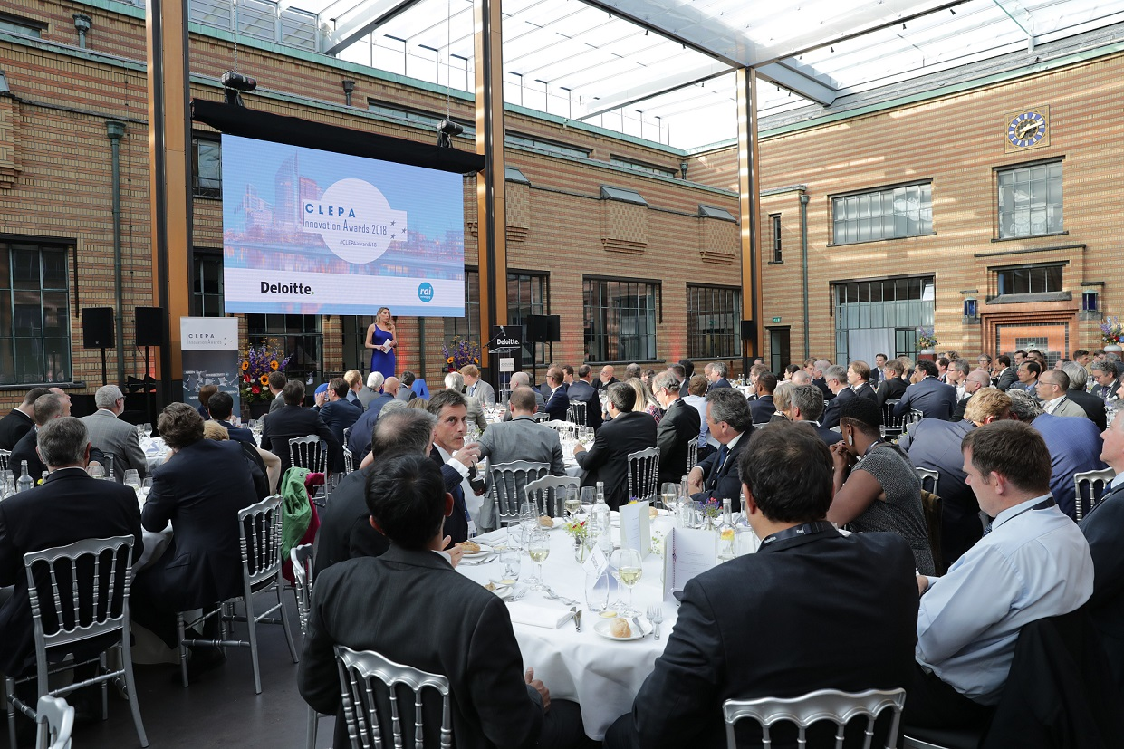

CLEPA, the European Association of Automotive Suppliers, organised on Wednesday 13th of June for the 3rd time in a row the CLEPA Innovation Awards Gala. Venue and location this time were the Gemeentemuseum in The Hague, Netherlands.

The CLEPA Innovation Awards, organised in cooperation with Deloitte and with the support of the Dutch member RAI, celebrate outstanding achievements in the European automotive supply industry in the fields of Environment, Safety, Connectivity and Automation and Cooperation.
For the first time, a special prize was awarded in each category to SMEs, acknowledging the important contribution of small and mid-sized companies to the industry’s resourcefulness, ingenuity and competitiveness.
Plastic Omnium, Bosch, TomTom and Inteva clinched victory in the respective above-mentioned categories. Brigade, Navads and Voxdale are the first SMEs ever to receive a dedicated “SME Award” – in the categories Connectivity and Automation, Cooperation and Safety respectively.

Not less than 130 guests from the key players in the European automotive supply industry attended the yearly event.
As it was the case for the two previous editions, the event took place in conjunction with the association’s yearly General Assembly meeting.

Roberto Vavassori, CLEPA President said: “Our industry is the leader in Europe in terms of new patents filed every year, and the winning innovations for 2018 testify of the ingenuity and creativity of our highly talented people. Solutions for refueling plug-in hybrid vehicles, sustainable clean diesel systems, smart assistance for electric vehicles, or advanced rider assistance for two-wheelers: these are just examples of how European companies promote a better environment, well-being for citizens, and increased safety and convenience for more integrated mobility solutions; from two to four wheels, from private to public transport. Only through continuous innovation we will maintain European leadership in the present and the future.”

Sigrid de Vries, CLEPA’s Secretary General underlined the significance of the record 63 applications: “Digitalisation and sustainability are transforming the automotive industry as well as the vehicle population on the roads. This year, the CLEPA awards see a great diversity in terms of company background, focus, size and activity. It is great to celebrate such excellence across the sector. I’d like to thank our Innovation Awards partner Deloitte, the members of the jury, and all entrants for taking part in this journey. We hope to receive even more applications next year!”

AWARD CATEGORIES

ENVIRONMENT
– Winner: Plastic Omnium: Tanktronic - intelligent fuel system tailored for plug-in hybrid vehicles
- 2nd: Faurecia: EHRS – Exhaust Heat Recovery System
- 3rd: Eberspächer: Tunnel Mixer for sustainable clean diesel systems
SAFETY
- Winner: Bosch – advanced rider assistance systems for motorcycles
- 2nd: Veoneer – LIV 2.0 context-aware research platform
- 3rd: Continental – MFC500 camera, merging computer vision and surround view
- SME Winner: Brigade - Quiet Vehicle Sounder, making silent vehicles safer

CONNECTIVITY & AUTOMATION
- Winner: TomTom – EV service, bringing the EV driver peace of mind
- 2nd: Veoneer - LIV 2.0 context-aware research platform
- 3rd: Bosch – mySPIN, Smartphone Integration in motorcycle infotainment systems
- SME Winner: Navads – Presence Management Platform for digital visibility and smart mobility
COOPERATION
- Winner: Inteva - real-time scanning for stitching automotive interiors
- 2nd: Magna – carbon fiber subframe for vehicles
- 3rd: Maxion Wheels – Acorus, a reinvention of the wheel
- SME Winner: Voxdale: consortium for a Formula E racing team

Once more, a distinguished jury of international experts selected the above innovations as they scored highest marks in terms of ambition, market relevance, impact and quality of the innovation:

Connectivity & Automation
Arjen Bongard
Automotive IT
Magnus Granstrom
Chalmers

Cooperation
Margriet van Schijndel-de Nooij
EARPA- Association of Automotive R&D organisations
Chris Mason
FISITA

Environment
Greg Archer
Transport & Environment
Zizi Samaras
Thessaloniki University

Safety
Antonio Avenoso
ETSC- European Transport Safety Council
Michiel van Ratingen
Euro NCAP
Laurianne Krid
FIA Region I

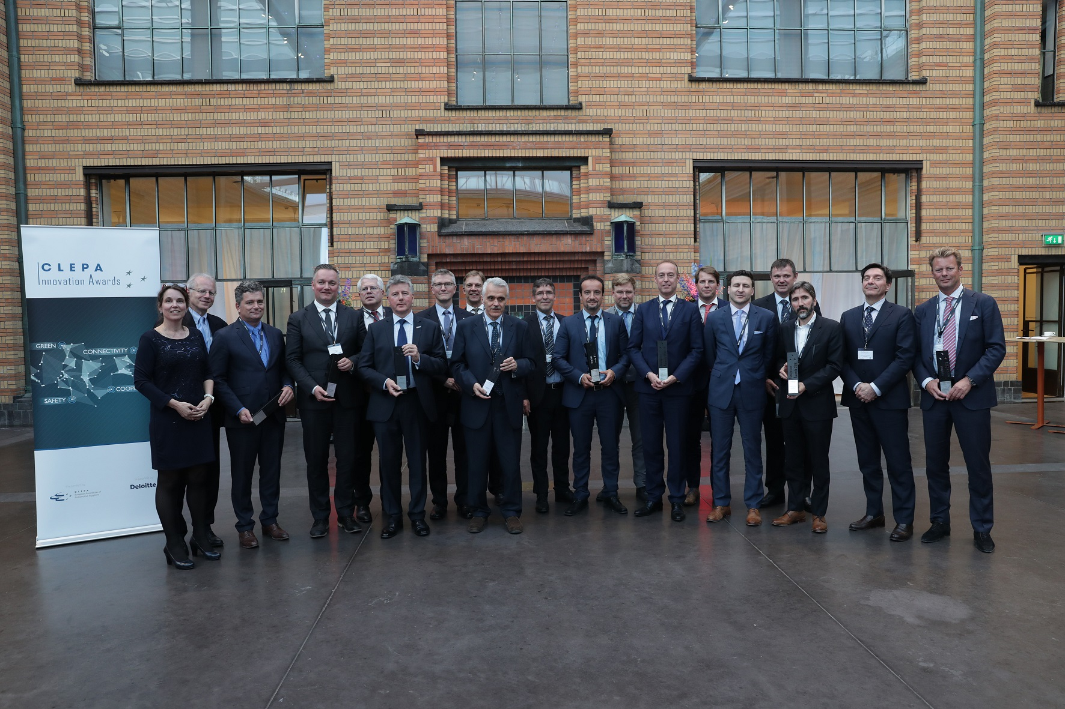

Note to the editor:
CLEPA represents over 3.000 companies supplying state-of-the-art components and innovative technology for safe, smart and sustainable mobility, investing over 20 billion euros yearly in research and development. Automotive suppliers in Europe employ nearly five million people across the continent.

For more information, please contact:
Pilar Perez (p.perez@clepa.be)

